Bug 1: Test Output

# Game does not pay out at correct level

Specifically if a user wins on 1 match the balance does not increase.

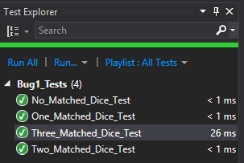

Test Name: No_Matched_Dice_Test

Test Outcome: Passed

Result StandardOutput: there were 0 matches

Test Name: One_Matched_Dice_Test

Test Outcome: Passed

Result StandardOutput: there were 1 matches

Test Name: Two_Matched_Dice_Test

Test Outcome: Passed

Result StandardOutput: there were 2 matches

Test Name: Two_Matched_Dice_Test

Test Outcome: Passed

Result StandardOutput: there were 3 matches